

Game of the hangman

CSC202: Object Oriented programming

Done by:

|  |  |
| --- | --- |
| Mirza Nabil Shuja | 1052128 |
| Talha Sheikh | 1050815 |

* **Abstract**

The aim of this project is to make a simple hangman game using the techniques of object oriented programming. The game allows users to guess a word from two categories and has only 7 tries till the game finishes. The core of the game is written in classes while the execution is done in the main function. For this program we are using four classes. The first class is an abstract class which is used only by the other classes for its function since we cannot create an object out of it. It has a member function called chosen which is initialized to zero. It also holds a constant integer used by the rest of the classes for its functions. The superclass is called the base which is inheriting from the abstract and overrides the function defined in the abstract. It has a member function that prints an image of a hanged man if user fails. It also has a friend function to allow the access to that function easier in the void main. Then we have two more classes both holding similar function that returns a value to check what the user types is correct or not.

* **Code**

#include <iostream>

#include <string>

#include <vector>

#include <fstream>

#include <cstdlib>

#include <ctime>

using namespace std;

class random { //abstract

public:

virtual int chosen() = 0;

int const lim = 7;

};

class base :public random { //super, Inheritance

public:

base() {};

int chosen() {

return rand() % lim;

}

void arrayhanged() {

cout << "\t O " << endl;

cout << "\t/ | \\ " << endl;

cout << "\t | " << endl;

cout << "\t/ \\ " << endl;

}

friend void ArrayFileOutput(int); //friend function

};

//computer selection

class computer :public base {

public:

computer() :base() {}

string word[7] = { "monitor","mouse","keyboard","memory","disk","motherboard","processors" };

int anstype(char ans, string d, string& u) {

int b = 0;

for (int i = 0; i< d.length(); i++) { //value return

if (ans == u[i])

return 0;

if (ans == d[i]) {

u[i] = ans;

b++;

}

}

return b;

}

~computer() {};

};

//country selection

class country :public base {

public:

country() :base() {}

string word[7] = { "india", "pakistan", "afghanistan", "egypt", "finland", "france", "argentina" };

int anstype(char ans, string c, string& u) {

int b = 0;

for (int i = 0; i< c.length(); i++) { //values return

if (ans == u[i])

return 0;

if (ans == c[i]) {

u[i] = ans;

b++;

}

}

return b;

}

~country() {};

};

int main() {

srand(time(NULL));

computer c1; //initializes computer object

country c2; //initializes country object

char ans; // user input

int mis = 0; // user's mistake count

string wha; //yes or no?

base a; //calls the random number generator

int b = a.chosen(); //random is added into b

string c = c1.word[b]; //the word is now equal to c (the chosen one)

string d = c2.word[b]; //the word is now equal to d (the chosen one)

string u(c.length(), 'x'); //example: xxxx

string u2(d.length(), 'x');

cout << "\t\tWelcome to Hangman!\n\n";

cout << "The category is of your choice: \n";

base* i[2] = { &c1, &c2 }; //pointer using the superclass and array

do {

cout << "Enter 0 - computer \nEnter 1 - country: \n";

int input;

cin >> input; //users choice

//computer

if (input == 0) {

cout << "The length of the word is " << c.length() << " characters" << endl;

while (mis < 7) {

cout << u;

cout << "\n\nGuess a letter: ";

cin >> ans;

if (c1.anstype(ans, c, u) == 0) {

//object used to call the function of the class

cout << endl << "Wrong Letter." << endl;

mis++;

}

else {

cout << endl << "You found a letter" << endl;

}

cout << "You have " << 7 - mis;

cout << " guesses left." << endl;

if (c == u) {

cout << "Congratulation !!! You passed my word. Play again ? Yes / No" << endl;

cin >> wha;

break;

}

if (mis == 7) {

cout << "Sorry you failed. The word was: " << c << "\n";

i[input]->arrayhanged(); //pointer doing its work

cout << " Play again ? Yes / No " << endl;

cin >> wha;

break;

}

ArrayFileOutput(mis);

}

}

//country

else if (input == 1) {

cout << "The length of the word is " << d.length() << " characters" << endl;

while (mis < 7) {

cout << u2;

cout << "\n\nGuess a letter: ";

cin >> ans;

if (b == b) {

if (c2.anstype(ans, d, u2) == 0) {

cout << endl << "Wrong Letter." << endl;

mis++;

}

else {

cout << endl << "You found a letter" << endl;

}

cout << "You have " << 7 - mis;

cout << " guesses left." << endl;

if (d == u2) {

cout << "Congratulation !!! You passed my word. Play again ? Yes / No" << endl;

cin >> wha;

break;

}

if (mis == 7) {

cout << "Sorry you failed. The word was: " << d << "\n";

i[input]->arrayhanged();

cout << " Play again ? Yes / No " << endl;

cin >> wha;

break;

}

}

}ArrayFileOutput(mis);

// system("cls");

}

else {

cout << "Input is invalid, Try again by pressing yes: \n";

cin >> wha;

}

} while (wha == "Yes" || wha == "yes");

return 0;

}

void ArrayFileOutput(int m) {

ofstream fout("hangman.txt");

if (fout.is_open()) {

if (m == 0) {

fout << "\tO " << endl;

}

else if (m == 1) {

fout << "\t O " << endl;

fout << "\t/ " << endl;

}

else if (m == 2) {

fout << "\t O " << endl;

fout << "\t/ | " << endl;

}

else if (m == 3) {

fout << "\t O " << endl;

fout << "\t/ | \\" << endl;

}

else if (m == 4) {

fout << "\t O " << endl;

fout << "\t/ | \\" << endl;

fout << "\t | " << endl;

}

else if (m == 5) {

fout << "\t O " << endl;

fout << "\t/ | \\" << endl;

fout << "\t | " << endl;

fout << "\t/ " << endl;

}

else if (m == 6) {

fout << "\t O " << endl;

fout << "\t/ | \\" << endl;

fout << "\t | " << endl;

fout << "\t/ \\" << endl;

}

fout.close();

cout << "Data is written to file.\n";

}

else {

cout << "The file cannot be opened.\n";

}

}

**Results**

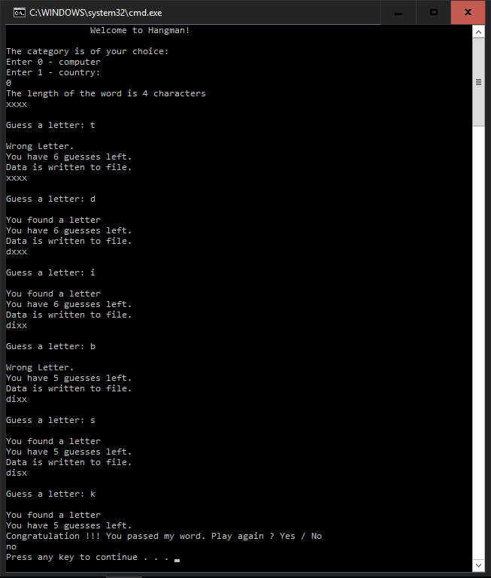

**Result printed onto a text file**

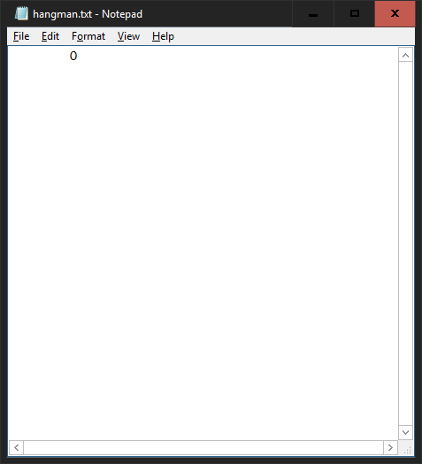

**Second Result**

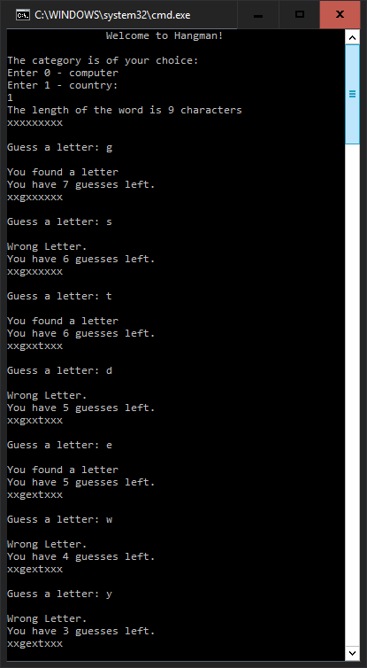

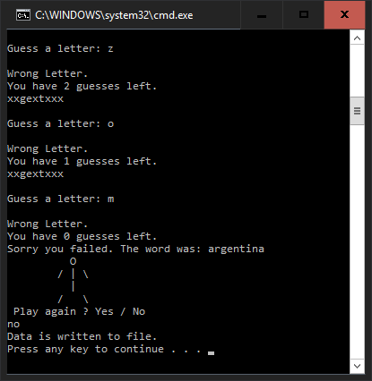

**Result printed onto a text file**

